**COMP211 Database Design**

**Class Practice 4 Enhanced Entity-Relationship Modeling**

Introduce specialization / generalization concepts into the following ER model.

1. For the owners own propertyForRent relationship, an owner must be either a PrivateOwner or a BusinessOwner. **Attributes of PrivateOwner include**: a unique ownerNo, name (first name, last name), address, telNo**. Attributes of BusinessOwner include:** a unique ownerNo, businessName, businessType, address, telNo, contactName.

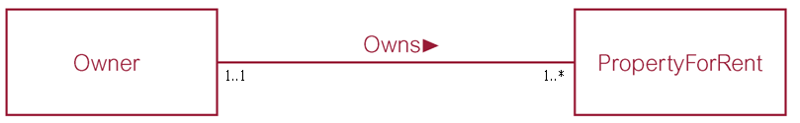

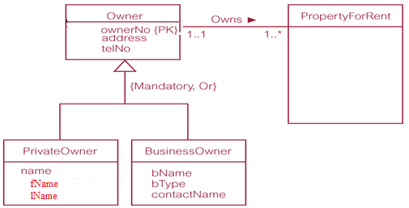

1. Members of staff may be assigned either as Supervisor or Manager. Supervisor is allocated to a group of staff (up to a maximum of 10) with a team name. Not all members of staff are assigned to a Supervisor. Manager manages a branch and every branch has a manager. Manager has a date when he assumed his position at the current branch and a monthly bonus based upon his/her performance.

